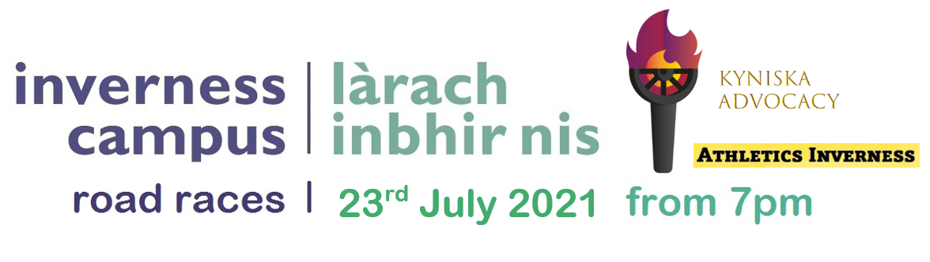
Inverness Campus Road Races 2021
Supporting Kyinska Advocacy
Please read before Sign Up
Many thanks for entering the Inverness Campus 5k Road Races, we are delighted to be able to bring you a race in 2021 emerging out of these difficult times. We have guidelines in place, many of which are required to meet keep you safe and stay within the guidelines of Scottish Athletics. At this time of writing (28.06.21) Highland is in Level 1 and the race is anticipated to still be within Level 1 restrictions. However, our Covid-19 protocols are enhanced and are as follows;
Covid-19
Runners are required to wear face coverings from the time you arrive until you are in the warm-up area prior to race start. Runners must observe the 2m social distancing guidelines.
Face coverings must be carried by all runners during the race to allow for assistance from marshals or first aiders if required.
Face coverings must be put back on as soon as runners come through the finish line and runners must then observe social distancing, including from those in their waves.
Covid Rules Inverness Campus 5k Road Races, please do not attend the event if you:
- Have been in contact with someone with COVID-19 in the last 14 days.
- Have been overseas to a country on the quarantine list or exposed to someone with COVID-19 in the last 14 days.
- Have COVID-19 symptoms (self-isolate for 10 days) or are feeling unwell.
- Have been told to self-isolate as part of the contact tracing measures in place.

Spectators
Due to Covid-19 restrictions, spectators are not encouraged and we ask all runners to respect this. Any athlete (especially U18’s) can have one chaperone who must give their contact tracing details at registration of the athlete.
Parking
Runners must follow Scottish Government guidance with regard to car sharing. Limited Car Parking will be available on site to the right of the main roundabout coming into the campus, parking in the gravel visitors car park. Please note that this car park will likely fill up early and no other parking is permitted on site including at HIE, UHI other business car parks with the nearest available parking at Inshes Retail Park. The Race information point will be signposted on arrival and will be adjacent to the start. No changing on site.
Online Entry and Entry Fees:
Entries will close at midnight 16 July 2021 or when filled up. EntryCentral will show the race as 'Closed' after this time.
ENTRY FEE IS £15 FOR SA MEMBERS AND £17 FOR NON-SA MEMBERS.
Registration
Open from 6.00pm and located outside at the Start, the Race information point is where to collect race numbers. Registration for each race will close 15 mins before the start.
Runners must wear face coverings during Registration.
Race 1 5k Open runners should arrive promptly by 6.30pm.
Race 2 5k Elite runners arriving at 6.35pm and NOT before and collect by 6:50pm. Please register and then move away from the Registration area. Runners must observe social distancing when registering.
Runners who are late to registration will not be allowed to register and then run.
Race numbers
Your race number should be secured to the front of your kit using safety pins. It must be worn on the garment that will be visible when you finish the race. Runners should bring their own pins.
Due to NHS Test and Protect, runners are not permitted to transfer their number to another runner. Any runner found to be racing with another runner’s number will be disqualified.

Facilities
There are no toilets or changing facilities available at the start / finish area due to Covid-19 restrictions. Runners should arrive ready to run. Any runner found to be using the surrounding area as a toilet will be disqualified. Toilets are available at two retail parks within 10 mins out and back run time.
All runners kit is the responsibility of runners and should not be discarded out with of vehicles.
Race details
7:00pm 5k OPEN
RACE 1 will consist of athletes with known PB times upwards of 17:30 mins.
7:30pm 5k ELITE
RACE 2 will consist of athletes with known PB times below 17:30 mins.
The race will have two waves of up to 50 athletes, based on the estimated times you provided on entering. Runners must not swap waves. Race 1 5k OPEN will start at 7:00pm and Race 2 5k ELITE at 7:30pm.
Runners should run only on the marked course. Runners can pass other runners but should do so maintaining a 2m side by side rule.
Ear phones
For runners own safety, you are reminded that earphones are not permitted. Any runners wearing earphones will be removed from the race by marshals in line with UK Athletics rules to ensure your safety whilst out on public roads.
Start / Finish
The start/finish area will be opposite the Highlands & Islands Enterprise (HIE) building. For runners who have been at the Campus races previously the start is approximately set back 150m from last edition to avoid congested at first corner. Conversely the finish at now halfway down the main pavement straight to the roundabout at the side of the Inveness College UHI building. Both will be clearly marked with banners on race night. Runners should leave as soon as they have finished. Face coverings must be put back on as soon as runners come through the finish line and runners must then observe social distancing, including from those in their waves/races.
Due to Covid-19 restrictions there will be no water station on the course and runners are asked to carry their own water if they need it. Water bottles and other rubbish must not be discarded on the course. Any runner found to be discarding rubbish will be disqualified.

Prizes (Elite Race Only)
We are aiming for all of your entry fee (less costs/prize money) is being donated to Kyniska Advocacy, a wonderful organisation which is advocating for new and better policies that protect, respect, and celebrate women and girls in sport. This event is a primary fundraiser for this organisation and would love a big show of support not just for the races but for all involved in Kyniska Advocacy - www.kyniskaadvocacy.com
Female and Male winner, 2nd and 3rd will receive £100, £60, £40.
COURSE RECORDS
Men Kenny Wilson 14:42 12.07.19 - £50 for new course record
Women Mhairi MacLennan 16:39 13.07.18 - £50 for new course record
Any questions prior to the race or on the day
Ross Cairns 07773020486.
COURSE
The course is accurately measured and certificated for Power of 10 and is entirely on smooth traffic free path/road. Ideal for fast times.
http://coursemeasurement.org.uk/detail.php?area=Scotland&no=2019367﻿

